Source code:

Postman Assignment_001:

Create pet Id and pet name:

First create excel sheet and enter pet names pet id

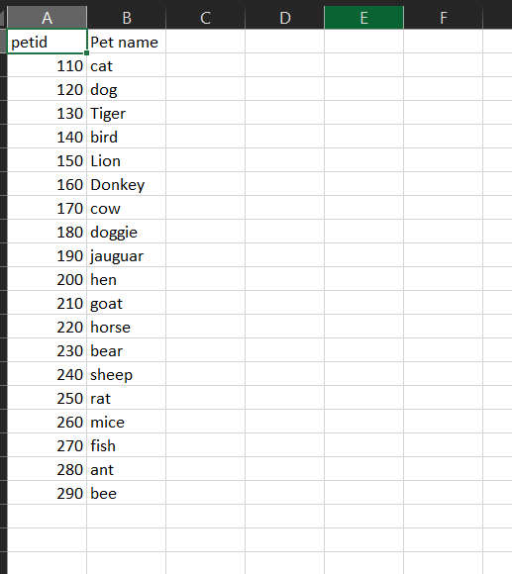

And save it as project pet id select as csv & delimeted & save as in desktop folder

● Open Postman

● Create a new collection called **Phase end project** and arrange three end-to-end services

as shown below:

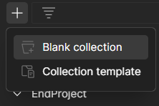

In this blank collection add new request

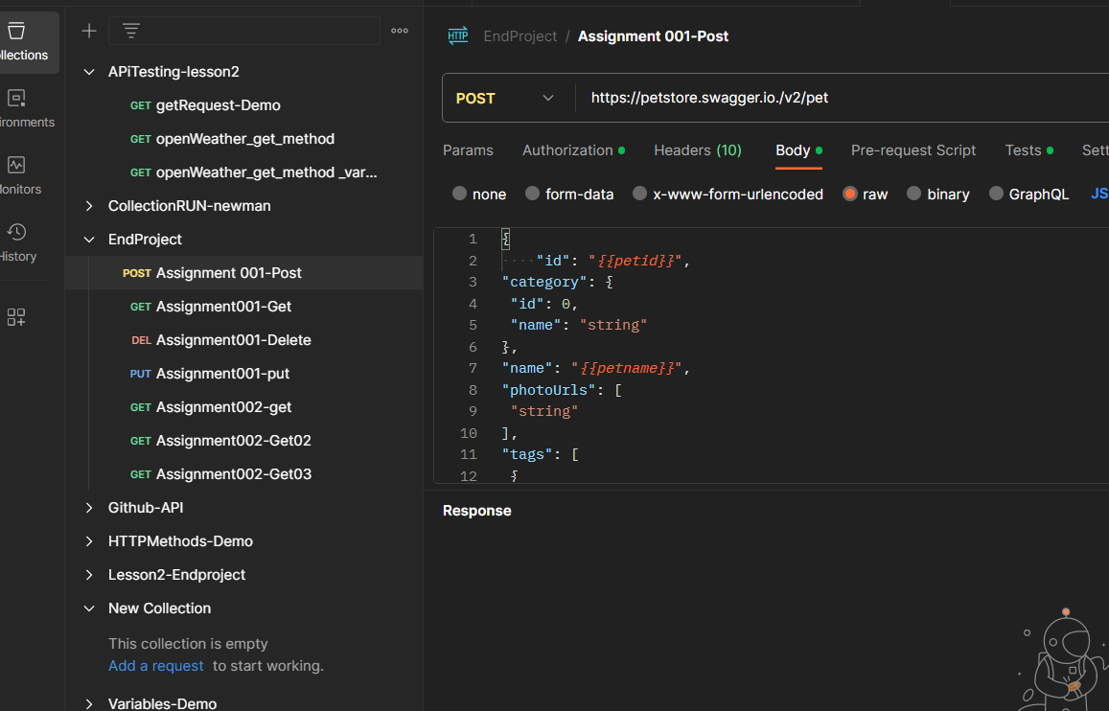

In this request part add Assignment_001-Post

<url:https://petstore.swagger.io./v2/pet>

in body part select raw area and select text as json

{

"id": "*{{petid}}*",

"category": {

"id": 0,

"name": "string"

},

"name": "*{{petname}}*",

"photoUrls": [

"string"

],

"tags": [

{

"id": 0,

"name": "string"

}

],

"status": "available"

}

{

"id": "*{{petid}}*",

"category": {

"id": 0,

"name": "string"

},

"name": "*{{petname}}*",

"photoUrls": [

"string"

],

"tags": [

{

"id": 0,

"name": "string"

}

],

"status": "available"

}

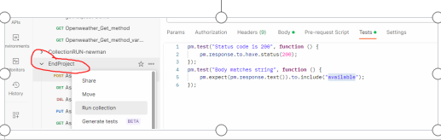

In this area add body part also

Go to end project click 3 dots select run collection

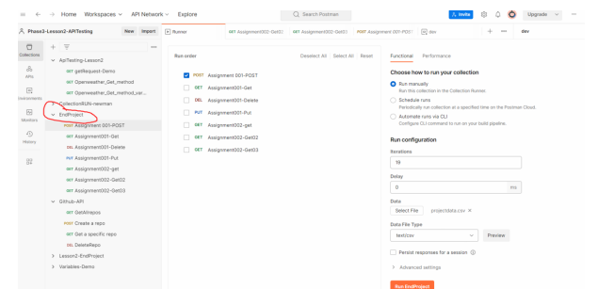

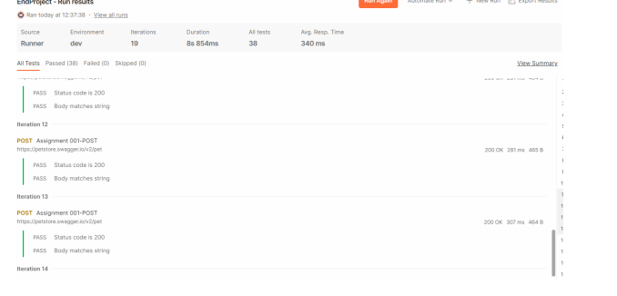

Next select postman-assignment001-get method

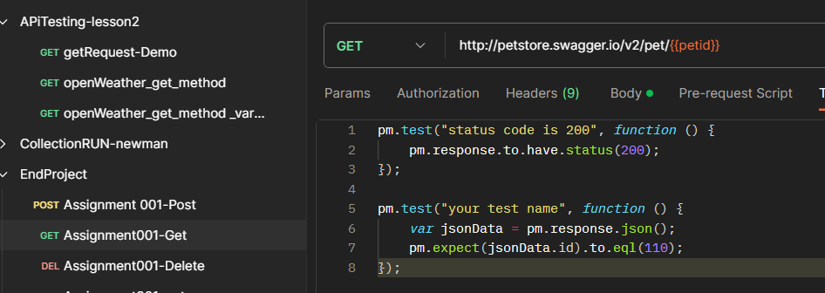

And add body value

{

"id": 110,

"category": {

"id": 0,

"name": "string"

},

"name": "cow",

"photoUrls": [

"string"

],

"tags": [

{

"id": 0,

"name": "string"

}

],

"status": "available"

}

This is output part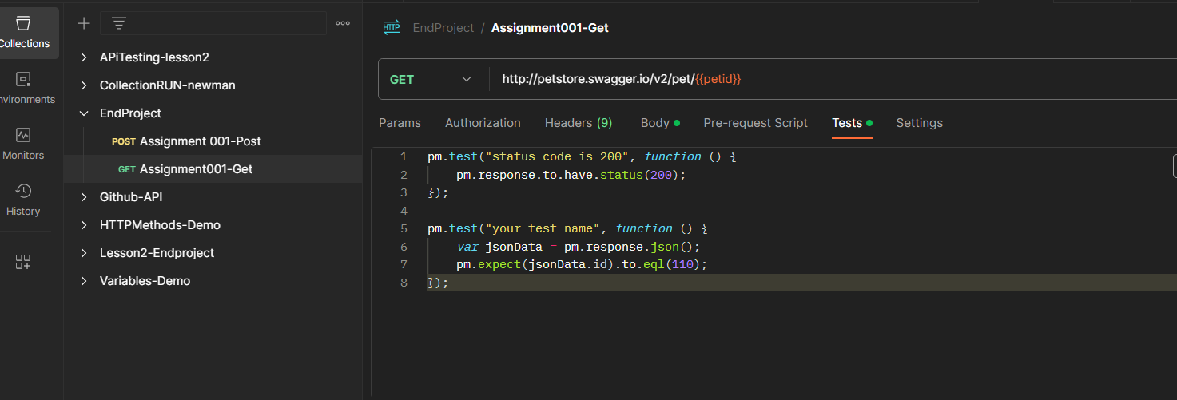

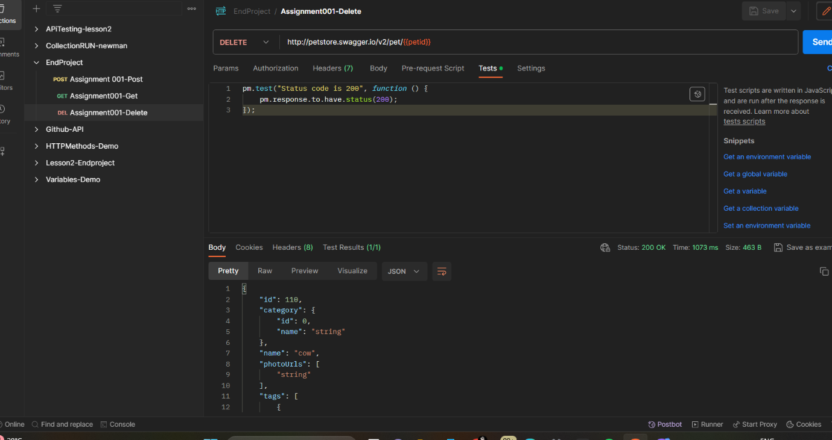

And next Take add request as delete – Assignment001-delete

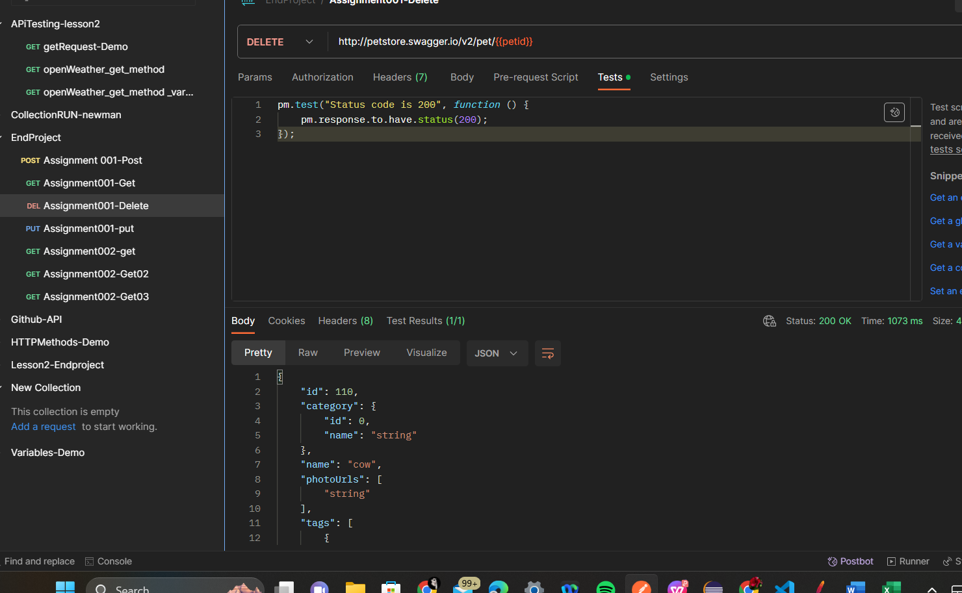

In this environment part select dev enter pet id & pet names

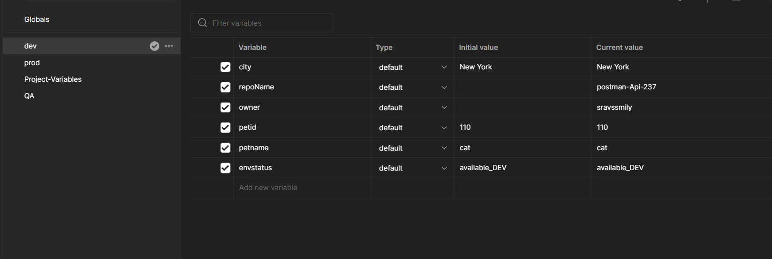

Next take Put assignment001-Demo

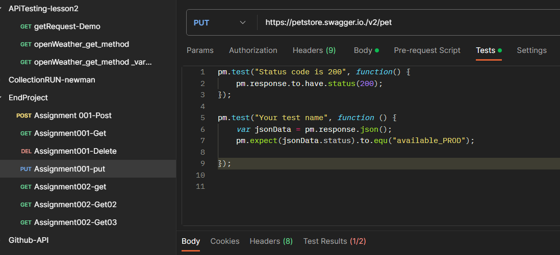

Next take put body part enter script

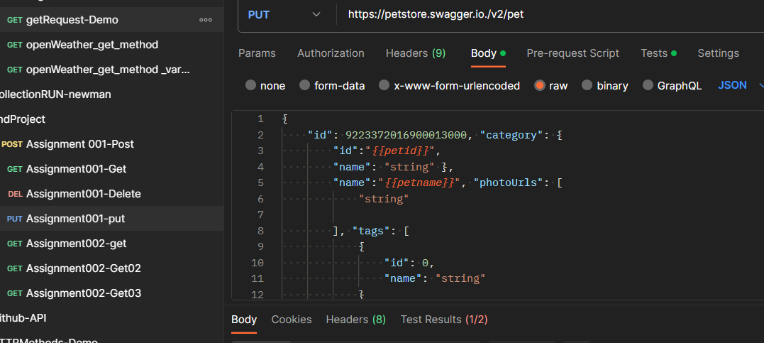

Its output part

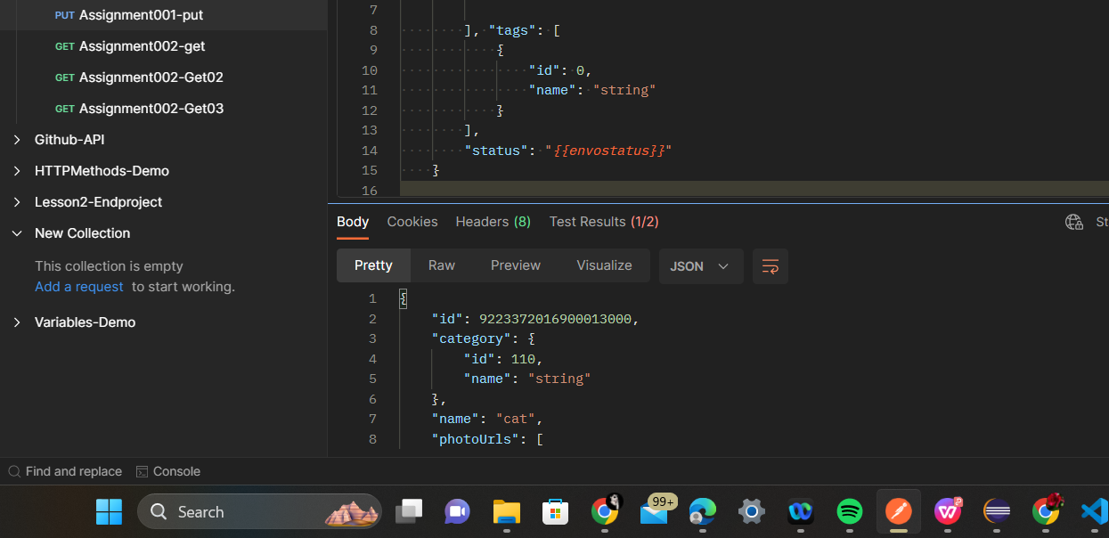

Next take get assignment002-get

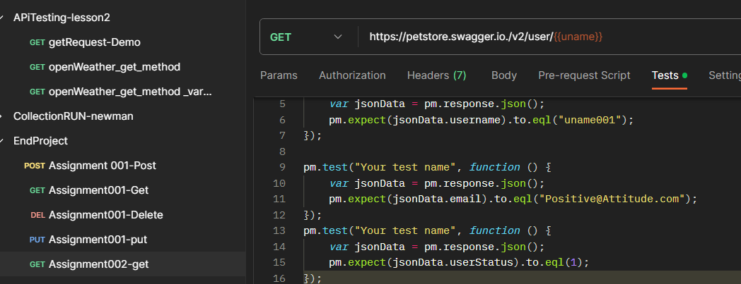

And select environment variables

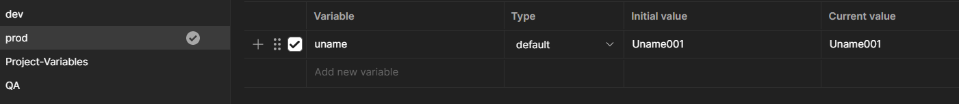

And next select Get Assignment002-get02 method

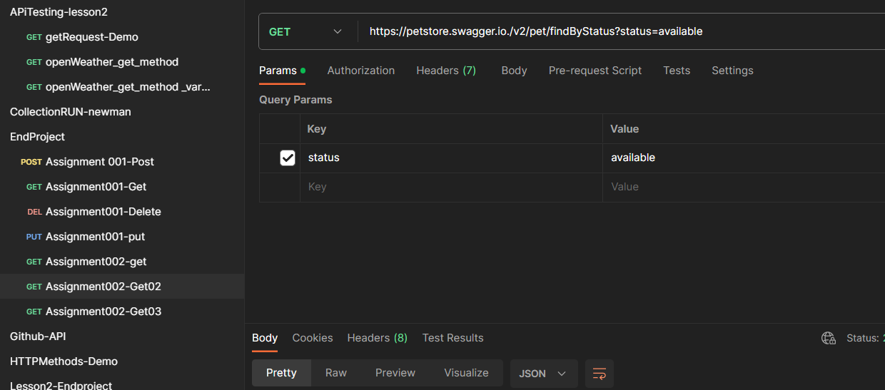

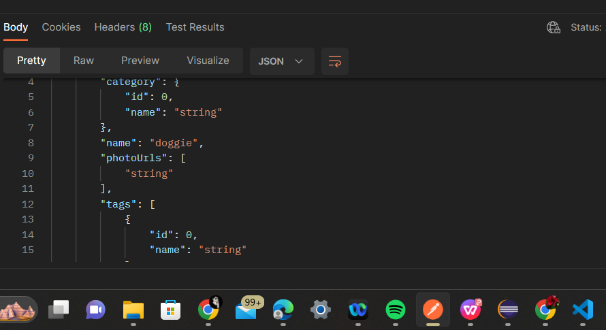

Next take Get Assignment002-Get 3 method

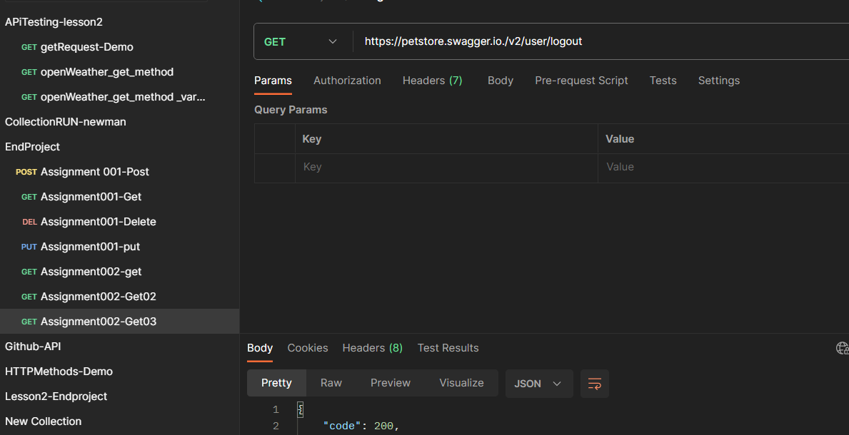

Next Take Rest Assured Assignments:

Go to eclipse part create a project resrassured scripts

Enter package name phase end project take class name Assignment001

package courseEndProject;

import java.io.File;

import org.apache.logging.log4j.LogManager;

import org.apache.logging.log4j.Logger;

import org.hamcrest.Matchers;

import org.testng.annotations.Test;

import io.restassured.RestAssured;

import io.restassured.http.ContentType;

public class Assignment001Demo {

Logger logger = LogManager.getLogger(Assignment001Demo.class);

@Test(priority='1')

public void assignment001Post()

{

logger.info("Course End project - Assignment001 - POST request");

File file = new File("resources/data.json");

int id = RestAssured.given()

.baseUri("https://petstore.swagger.io/v2/pet")

.contentType(ContentType.JSON)

.body(file)

.when().post()

.then()

.statusCode(200)

.log().all()

.body("name", Matchers.equalTo("duck")).extract().path("id");

logger.trace("The status code is checked");

System.out.println(id);

logger.trace("Id has been captured and validated");

}

@Test(priority='2',dependsOnMethods="assignment001Post")

public void assignment001Get()

{

logger.info("Course End project - Assignment001 - GET request");

int id = RestAssured.given()

.baseUri("https://petstore.swagger.io/v2/pet/987")

.when()

.get()

.then()

.statusCode(200)

.log().all()

.body("status", Matchers.equalTo("available")).extract().path("category.id");

System.out.println(id); // 0

logger.trace("Id and status has been captured and validated");

}

@Test(priority='3',dependsOnMethods="assignment001Get")

public void assignment001Delete()

{

logger.info("Course End project - Assignment001 - Delete request");

RestAssured.given()

.baseUri("https://petstore.swagger.io/v2/pet/987")

.when()

.delete()

.then()

.statusCode(200)

.log().all()

.body("code", Matchers.equalTo(200))

.body("type", Matchers.equalTo("unknown"))

.body("message", Matchers.equalTo("987"));

}

Output part:

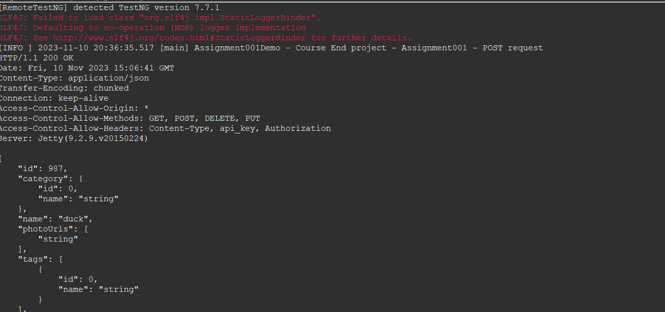

Next step is Assignment002 post.java

package courseEndProject;

import java.io.File;

import org.apache.logging.log4j.LogManager;

import org.apache.logging.log4j.Logger;

import org.hamcrest.Matchers;

import org.testng.annotations.Test;

import io.restassured.RestAssured;

import io.restassured.http.ContentType;

public class Assignment002Post {

Logger logger = LogManager.getLogger(Assignment002Post.class);

@Test(priority='1')

public void assignment002Post()

{

logger.info("Course End project - Assignment002 - POST request");

File file = new File("resources/data.json");

int id = RestAssured.given()

.baseUri("https://petstore.swagger.io/v2/pet")

.contentType(ContentType.JSON)

.body(file)

.when().post()

.then()

.statusCode(200)

.log().all()

.body("name", Matchers.equalTo("duck")).extract().path("id");

logger.trace("The status code is checked");

System.out.println(id);

logger.trace("Id has been captured and validated");

}

@Test(priority='2',dependsOnMethods = "assignment002Post")

public void assignment002Put()

{

File file = new File("resources/dataput.json");

int id = RestAssured.given()

.baseUri("https://petstore.swagger.io/v2/pet/")

.contentType(ContentType.JSON)

.body(file)

.when()

.post()

.then()

.statusCode(200)

.log().all()

.body("status", Matchers.equalTo("available_QA")).extract().path("id");

System.out.println(id);

}

}

Output:

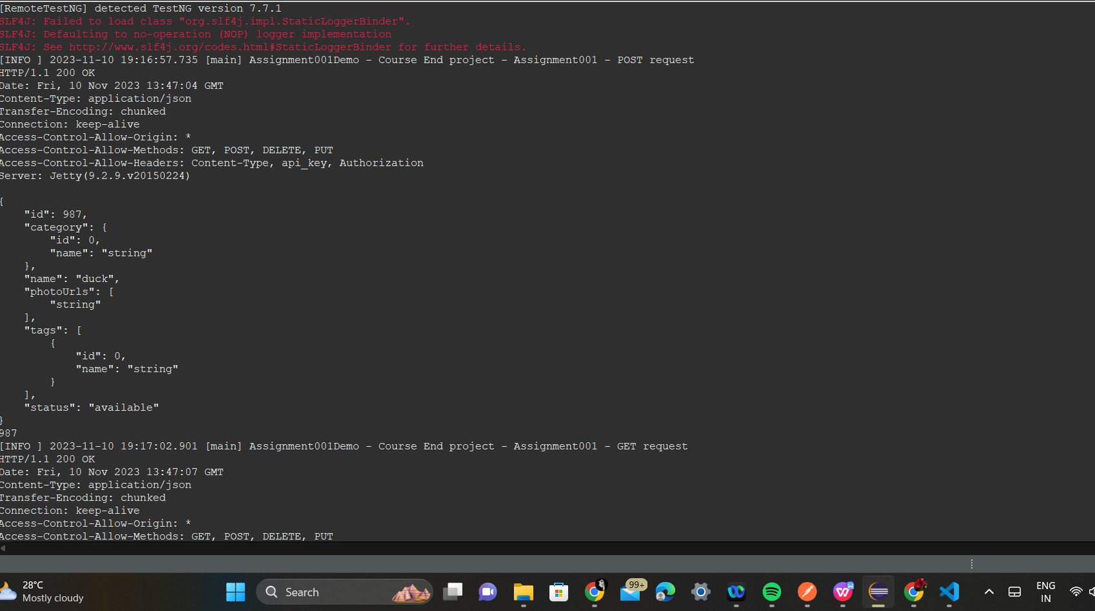

Next Assignment003 Demo.java

package courseEndProject;

import org.hamcrest.Matchers;

import org.testng.annotations.Test;

import io.restassured.RestAssured;

public class Assignment003Demo {

@Test(priority='1')

public void assignment003User()

{

RestAssured.given()

.baseUri("https://petstore.swagger.io/v2/user/Uname001")

.when()

.get()

.then()

.statusCode(200)

.log().all()

.body("username", Matchers.equalTo("Uname001"))

.body("email", Matchers.equalTo("Positive@Attitude.com"))

.body("userStatus", Matchers.equalTo(1))

;

}

@Test(priority='2')

public void assignment004login()

{

RestAssured.given()

.baseUri("https://petstore.swagger.io/v2/user/login")

.auth().preemptive().basic("Uname001", "@tt!tude")

.when()

.get()

.then()

.statusCode(200)

.log().all()

.body("message", Matchers.anything());

Next Assignment004

public void assignment004login()

{

RestAssured.given()

.baseUri("https://petstore.swagger.io/v2/user/login")

.auth().preemptive().basic("Uname001", "@tt!tude")

.when()

.get()

.then()

.statusCode(200)

.log().all()

.body("message", Matchers.anything());

Next take Assignment 005 Demo

package courseEndProject;

import org.hamcrest.Matchers;

import org.testng.annotations.Test;

import io.restassured.RestAssured;

public class Assignment005Demo {

@Test(priority='1')

public void assignment005FindByStatus()

{

RestAssured.given()

.baseUri("https://petstore.swagger.io/v2/pet/findByStatus")

//.queryParam("status", "available")

//.queryParam("status", "pending")

.queryParam("status", "sold")

.when()

.get()

.then()

.statusCode(200)

.log().all()

;

}

@Test(priority='2')

public void assignment006Logout()

{

RestAssured.given()

.baseUri("https://petstore.swagger.io/v2/user/logout")

.when()

.get()

.then()

.statusCode(200)

.log().all()

.body("code", Matchers.equalTo(200))

.body("type", Matchers.equalTo("unknown"))

.body("message", Matchers.equalTo("ok"))

;

}

}

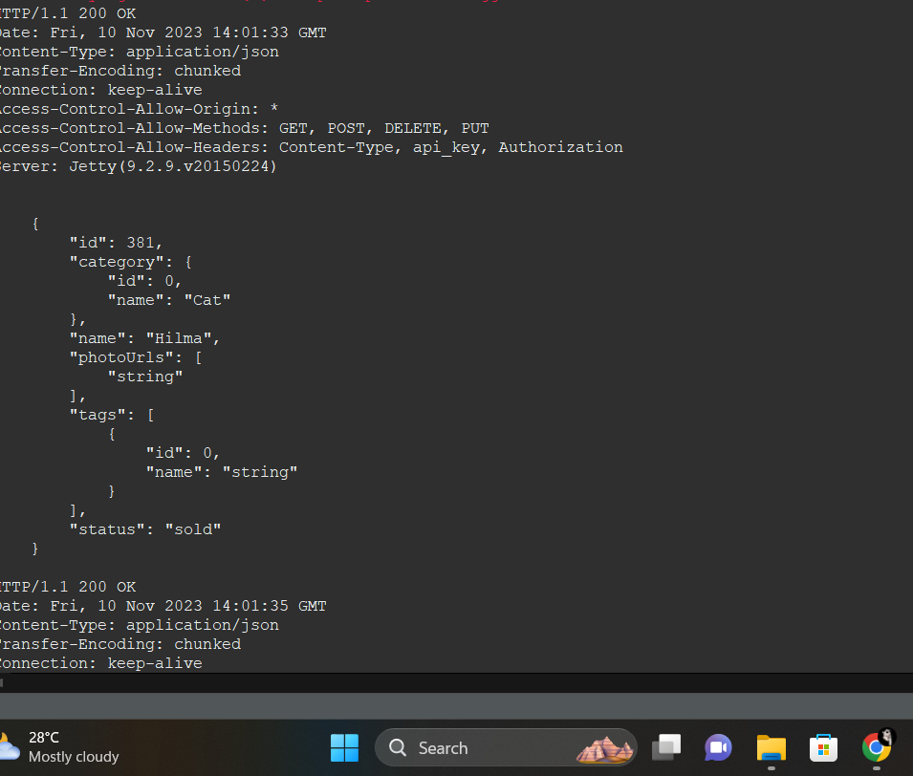

J meter part :

J meter part take simplilearn website

First go to j meter add test plan

In test plan add thread groups(user thread)

Add sampler request HTTP request

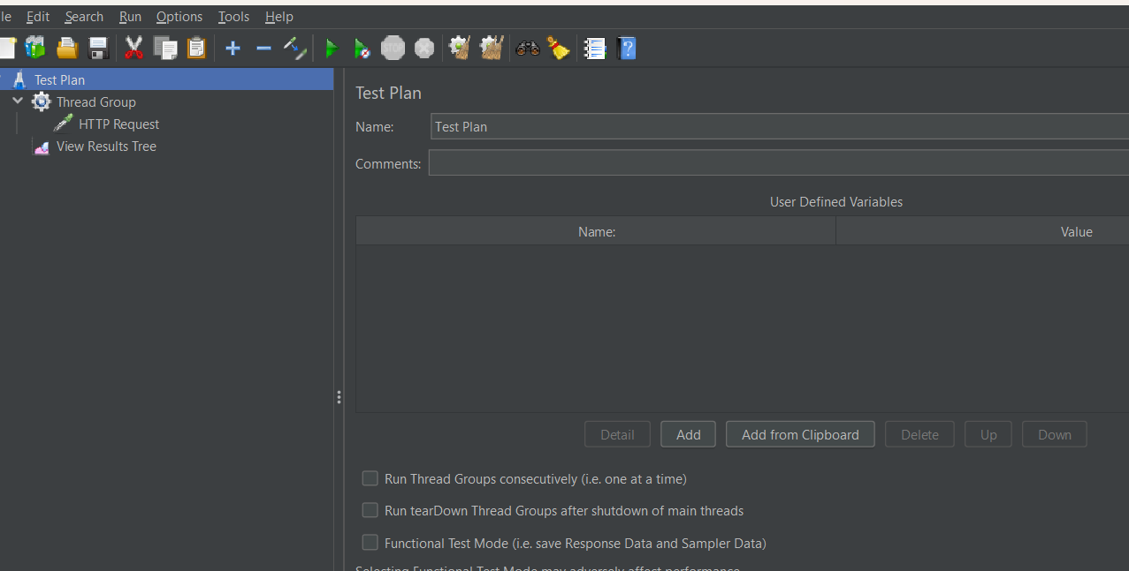

Add thread group

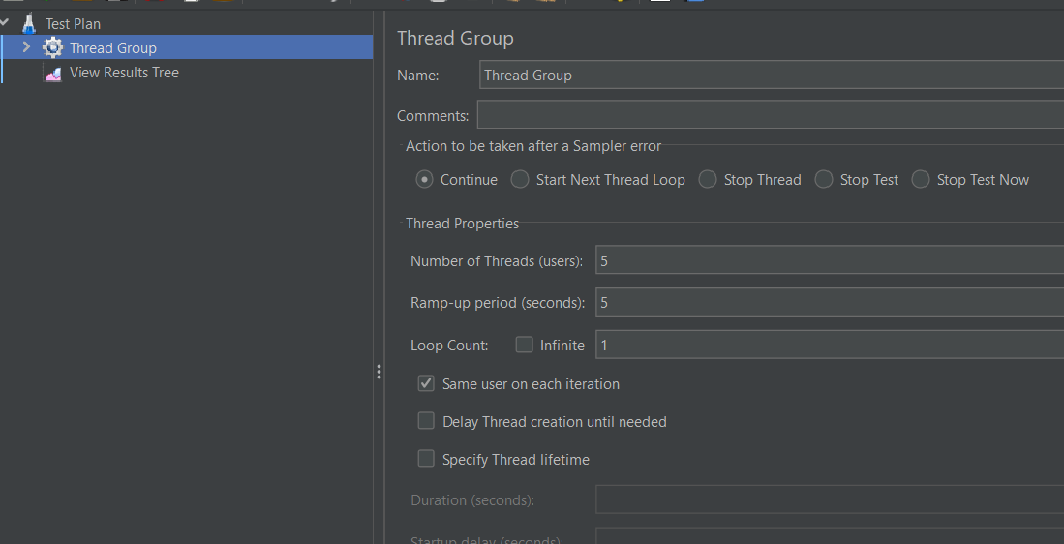

Create http request

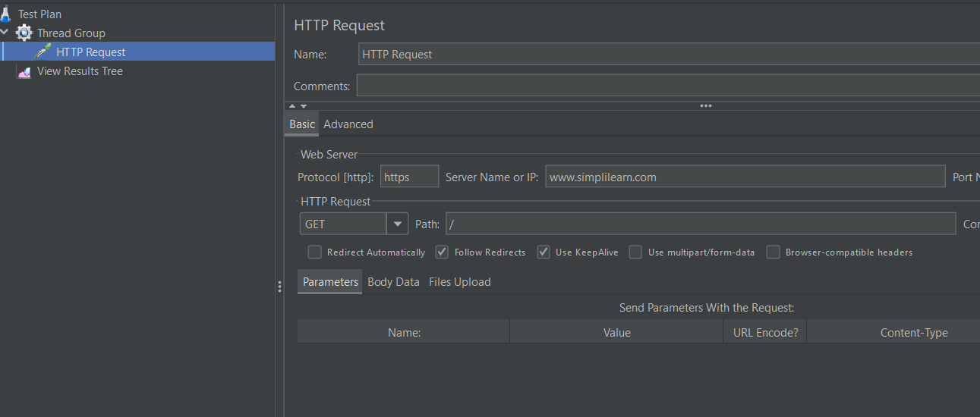

View results tree

